**EXPT NO: 1 A python program to implement univariate regression DATE: 23.8.24 bivariate regression and multivariate regression.**

# AIM:

To write a python program to implement univariate regression, bivariate regression and multivariate regression.

# PROCEDURE:

Implementing univariate, bivariate, and multivariate regression using the Iris dataset involve the following steps:

## Step 1: Import Necessary Libraries

First, import the libraries that are essential for data manipulation, visualization, and model building.

import numpy as np import pandas as pd

import seaborn as sns

import matplotlib.pyplot as plt

from sklearn.model_selection import train_test_split from sklearn.linear_model import LinearRegression

from sklearn.metrics import mean_squared_error, r2_score

## Step 2: Load the Iris Dataset

The Iris dataset can be loaded and display the first few rows of the dataset .

# Load the Iris dataset

iris = sns.load_dataset('iris')

# Display the first few rows of the dataset

print(iris.head())

# OUTPUT :

## Step 3: Data Preprocessing

Ensure the data is clean and ready for modeling. Since the Iris dataset is clean, minimal preprocessing is needed.

# Check for missing values print(iris.isnull().sum())

# Display the basic statistical details print(iris.describe())

# OUTPUT :

## Step 4: Univariate Regression

Univariate regression involves predicting one variable based on a single predictor.

## : Select the Features

Choose one feature (e.g., sepal_length) and one target variable (e.g., sepal_width).

X_uni = iris[['sepal_length']] y_uni = iris['sepal_width']

## : Split the Data

Split the data into training and testing sets.

Fit the linear regression model on the training data.

X_uni_train, X_uni_test, y_uni_train, y_uni_test = train_test_split(X_uni, y_uni,

test_size=0.2, random_state=42)

## : Train the model

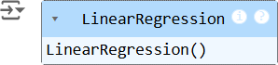

uni_model = LinearRegression() uni_model.fit(X_uni_train, y_uni_train)

* 1. **: Make Predictions**

Use the model to make predictions on the test data.

y_uni_pred = uni_model.predict(X_uni_test)

## : Evaluate the Model

Evaluate the model performance using metrics like Mean Squared Error (MSE) and R-squared.

print(f'Univariate MSE: {mean_squared_error(y_uni_test, y_uni_pred)}') print(f'Univariate R-squared: {r2_score(y_uni_test, y_uni_pred)}')

# OUTPUT :

## : Visualize the Results

Visualize the relationship between the predictor and the target variable.

plt.scatter(X_uni_test, y_uni_test, color='blue') plt.plot(X_uni_test, y_uni_pred, color='red') plt.xlabel('Sepal Length')

plt.ylabel('Sepal Width') plt.title('Univariate Regression') plt.show()

# OUTPUT :

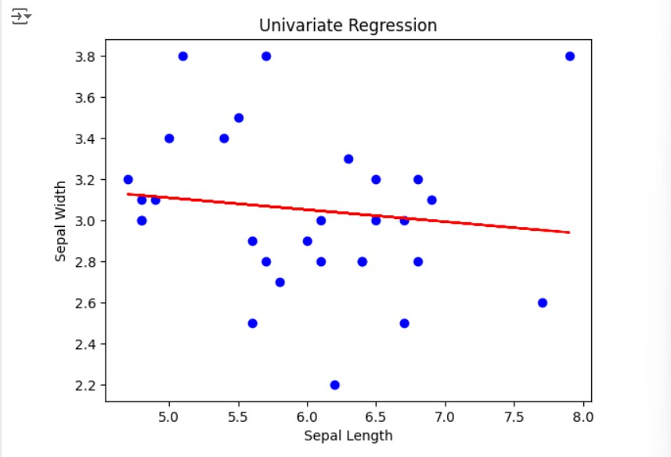

## Step 5 : Bivariate Regression

Bivariate regression involves predicting one variable based on two predictors.

## : Select the Features

Choose two features (e.g., sepal_length, petal_length) and one target variable (e.g., sepal_width).

X_bi = iris[['sepal_length', 'petal_length']]

y_bi = iris['sepal_width']

## : Split the Data

Split the data into training and testing sets.

X_bi_train, X_bi_test, y_bi_train, y_bi_test = train_test_split(X_bi, y_bi,

test_size=0.2, random_state=42)

## : Train the Model

Fit the linear regression model on the training data.

bi_model = LinearRegression()

bi_model.fit(X_bi_train, y_bi_train)

# OUTPUT :

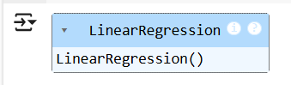

## : Make Predictions

Use the model to make predictions on the test data.

y_bi_pred = bi_model.predict(X_bi_test)

## : Evaluate the Model

Evaluate the model performance using metrics like MSE and R-squared.

print(f'Bivariate MSE: {mean_squared_error(y_bi_test, y_bi_pred)}') print(f'Bivariate R-squared: {r2_score(y_bi_test, y_bi_pred)}')

OUTPUT :



## : Visualize the Results

Since visualizing in 3D is challenging, we can plot the relationships between the target and each predictor separately.

# Sepal Length vs Sepal Width plt.subplot(1, 2, 1)

plt.scatter(X_bi_test['sepal_length'], y_bi_test, color='blue') plt.plot(X_bi_test['sepal_length'], y_bi_pred, color='red') plt.xlabel('Sepal Length')

plt.ylabel('Sepal Width')

# Petal Length vs Sepal Width plt.subplot(1, 2, 2)

plt.scatter(X_bi_test['petal_length'], y_bi_test, color='blue') plt.plot(X_bi_test['petal_length'], y_bi_pred, color='red') plt.xlabel('Petal Length')

plt.ylabel('Sepal Width')

plt.suptitle('Bivariate Regression') plt.show()

# OUTPUT :

## Step 6: Multivariate Regression

Multivariate regression involves predicting one variable based on multiple predictors.

## : Select the Features

Choose multiple features (e.g., sepal_length, petal_length, petal_width) and one target variable (e.g., sepal_width).

X_multi = iris[['sepal_length', 'petal_length', 'petal_width']]

y_multi = iris['sepal_width']

## : Split the Data

Split the data into training and testing sets.

X_multi_train, X_multi_test, y_multi_train, y_multi_test = train_test_split(X_multi,

y_multi, test_size=0.2, random_state=42)

## : Train the Model

Fit the linear regression model on the training data.

multi_model = LinearRegression() multi_model.fit(X_multi_train, y_multi_train)

# OUTPUT :

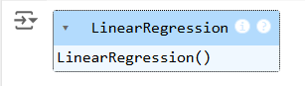

## : Make Predictions

Use the model to make predictions on the test data.

y_multi_pred = multi_model.predict(X_multi_test)

## : Evaluate the Model

Evaluate the model performance using metrics like MSE and R-squared.

print(f'Multivariate MSE: {mean_squared_error(y_multi_test, y_multi_pred)}') print(f'Multivariate R-squared: {r2_score(y_multi_test, y_multi_pred)}')

# OUTPUT :

**Step 7: Visualize the multivariate regression**

plt.figure(figsize=(15,4)) plt.subplot(1, 2, 1)

plt.scatter(X_multi_test['sepal_length'], y_multi_test, color='blue') plt.plot(X_multi_test['sepal_length'], y_multi_pred, color='red') plt.xlabel('sepal_length')

plt.ylabel('sepal_width')

plt.title('Multivariate Regression-1') plt.show()

plt.figure(figsize=(15,4)) plt.subplot(1, 2, 1)

plt.scatter(X_multi_test['petal_length'], y_multi_test, color='blue') plt.plot(X_multi_test['petal_length'], y_multi_pred, color='red') plt.xlabel('petal_length')

plt.ylabel('sepal_width')

plt.title('Multivariate Regression-2') plt.show()

plt.figure(figsize=(15,4)) plt.subplot(1, 2, 2 )

plt.scatter(X_multi_test['petal_length'], y_multi_test, color='blue') plt.plot(X_multi_test['petal_length'], y_multi_pred, color='red') plt.xlabel('petal_length')

plt.ylabel('sepal_width')

plt.title('Multivariate Regression-3') plt.show()

# OUTPUT :

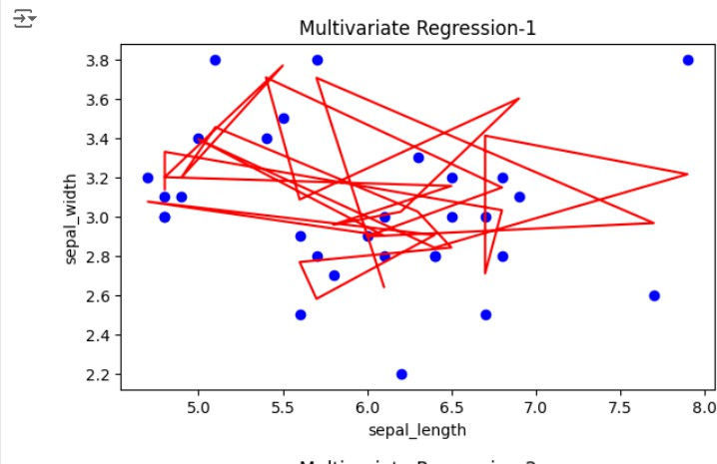

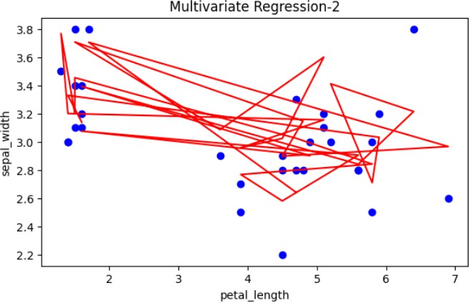

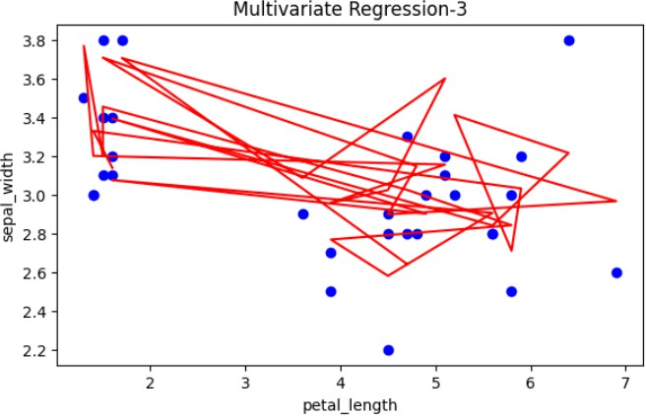

## Step 8: Interpret the Results

After implementing and evaluating the models, interpret the coefficients to understand the influence of each predictor on the target variable.

print('Univariate Coefficients:', uni_model.coef_) print('Bivariate Coefficients:', bi_model.coef_)

print('Multivariate Coefficients:', multi_model.coef_)

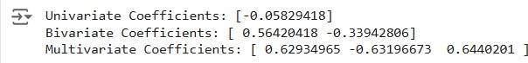**OUTPUT :**

# RESULT:

This step-by-step process will help us to implement univariate, bivariate, and multivariate regression models using the Iris dataset and analyze their performance.